1. Join the Oracle database locations and departments table using the location_id column. Limit the results to location 1400 only.

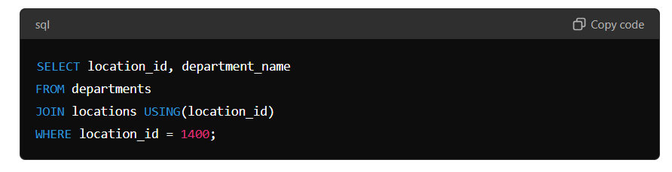2. Join DJs on Demand d_play_list_items, d_track_listings, and d_cds tables with the JOIN USING syntax. Include the song ID, CD number, title, and comments in the output.

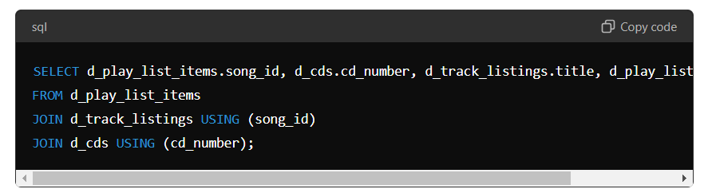

3. Display the city, department name, location ID, and department ID for departments 10, 20, and 30 for the city of Seattle.

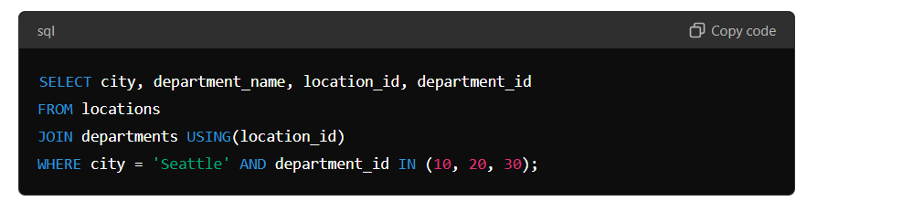

4. Display country name, region ID, and region name for Americas.

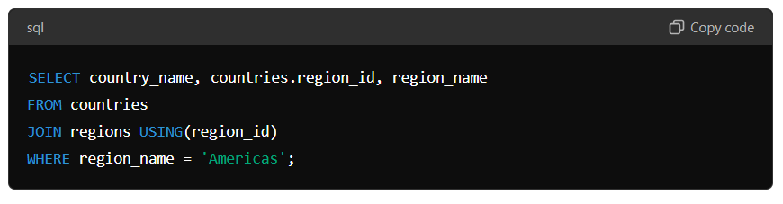

5. Write a statement joining the employees and jobs tables. Display the first and last names, hire date, job id, job title, and maximum salary. Limit the query to those employees who are in jobs that can earn more than $12,000.

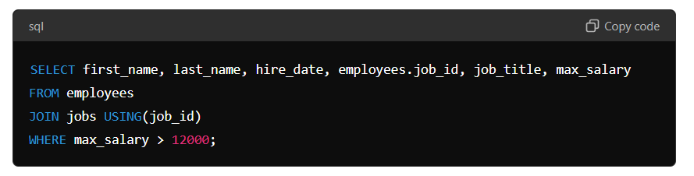

6. Display job title, employee first name, last name, and email for all employees who are stock clerks. Copyright © 2020, Oracle and/or its affiliates. All rights reserved. Oracle and Java are registered trademarks of Oracle and/or its affiliates. Other names may be trademarks of their respective owners. 2 The following questions use the JOIN…ON syntax:

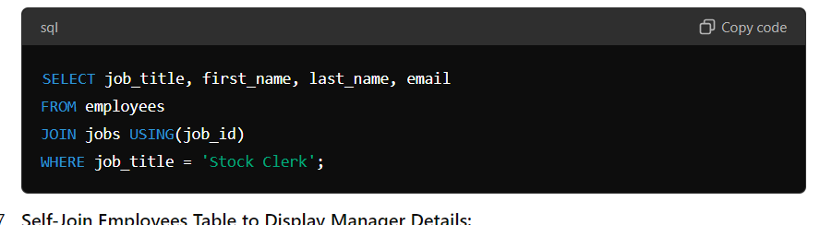

7. Write a statement that displays the employee ID, first name, last name, manager ID, manager first name, and manager last name for every employee in the employees table. Hint: this is a self-join.

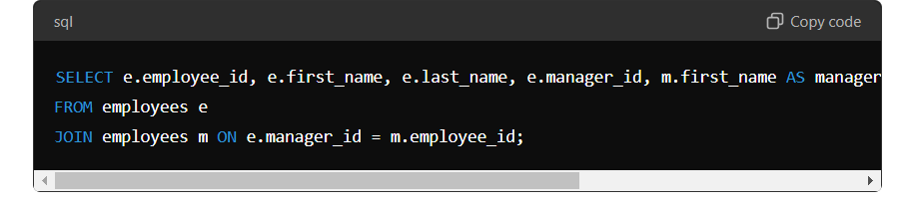

8. Use JOIN ON syntax to query and display the location ID, city, and department name for all Canadian locations.

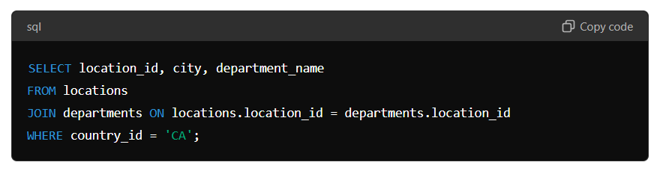

9. Query and display manager ID, department ID, department name, first name, and last name for all employees in departments 80, 90, 110, and 190.

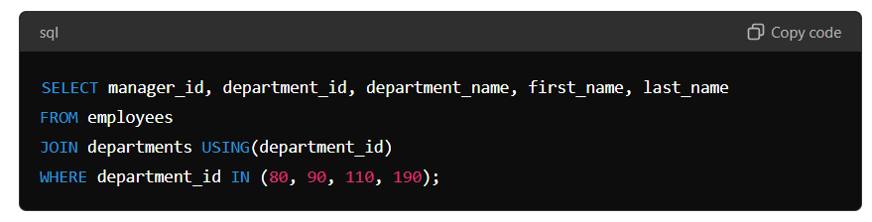

10.Display employee ID, last name, department ID, department name, and hire date for those employees whose hire date was June 7, 1994.

